# CS-643 Cloud Computing

## Programming Assignment 2 Rituben Patel

## Rtp23@njit.edu

## GitHub Link

<https://github.com/RPT23/pa2.git>

## Docker Link

<https://hub.docker.com/repository/docker/ritu757/patelcs643-pa2-aws-spark/general>

# SECTION 1: AWS Cloud setup for running the ML training application - training.py

## Step 1: Create S3 bucket and upload all necessary files to it.

After logging into AWS Console -> navigate to S3 service.

Create a new bucket by giving a unique name and keeping all default settings.

After creating the bucket, click on Upload and add the following files:

* TrainingDataset.csv
* ValidationDataset.csv

Follow the screenshots below for guidance

## Step 2: Create an EMR cluster

## Login to AWS Console and search for EMR in the search bar.

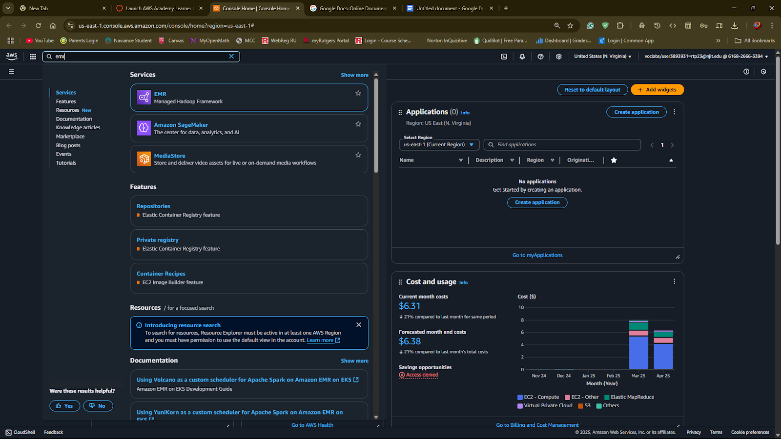

## Now Click on Create cluster and configure the following:

## Choose Spark as the software.

## Configure networking, permissions, and other settings as required.

Follow the screenshots below to correctly configure the EMR cluster

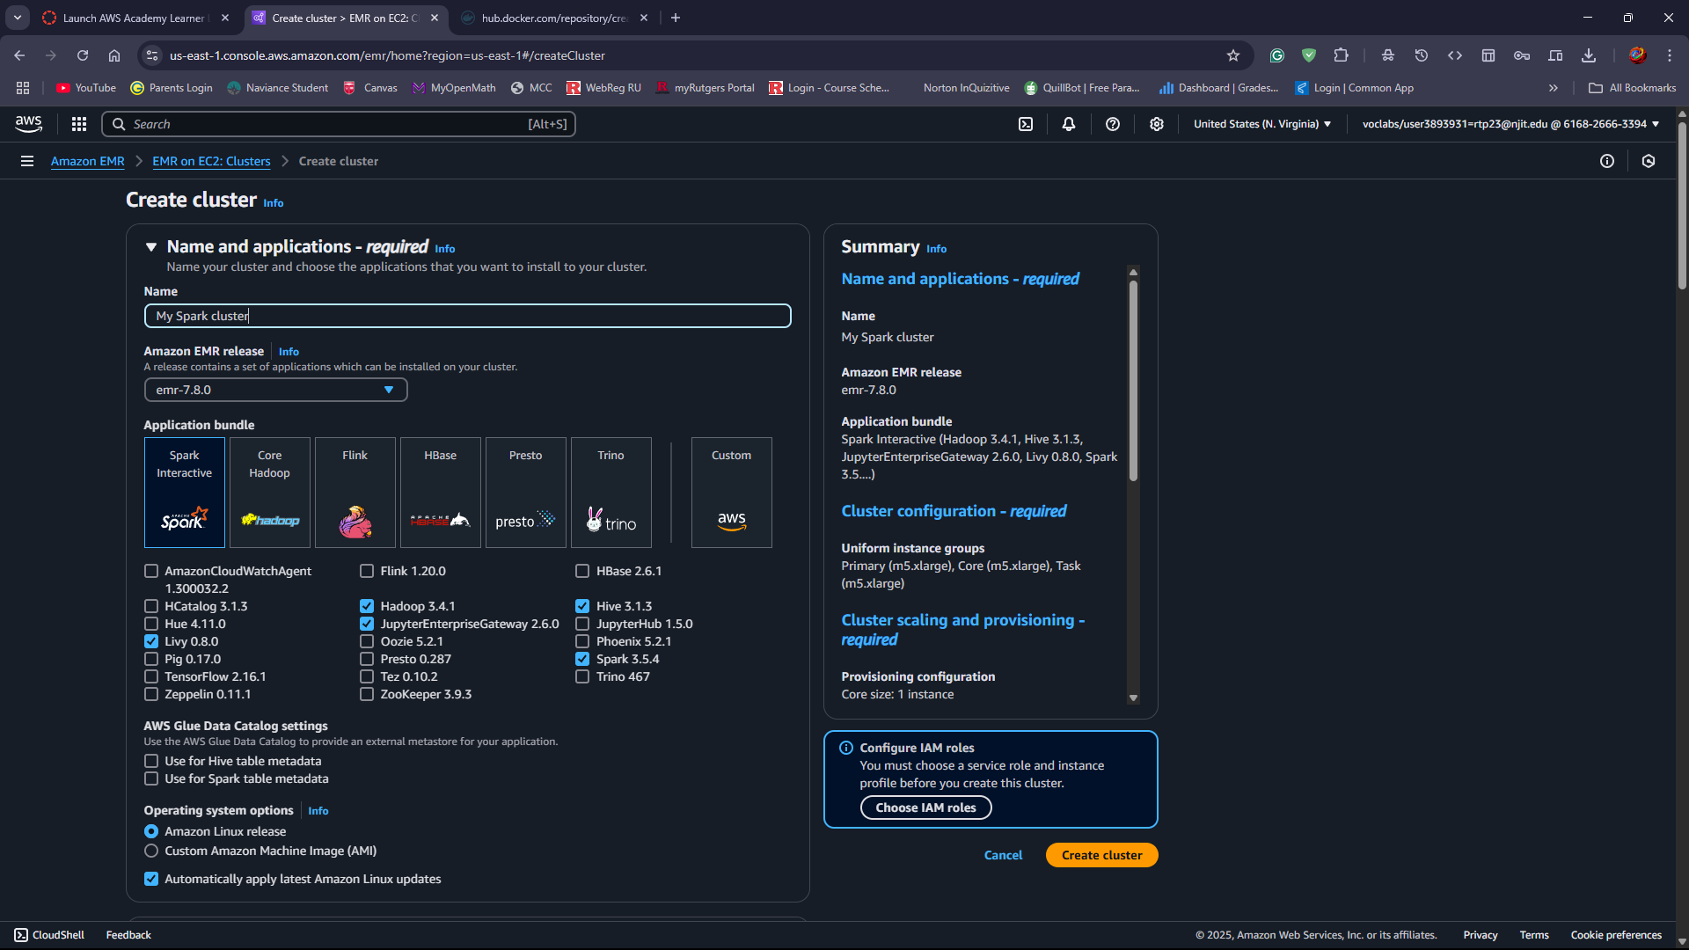

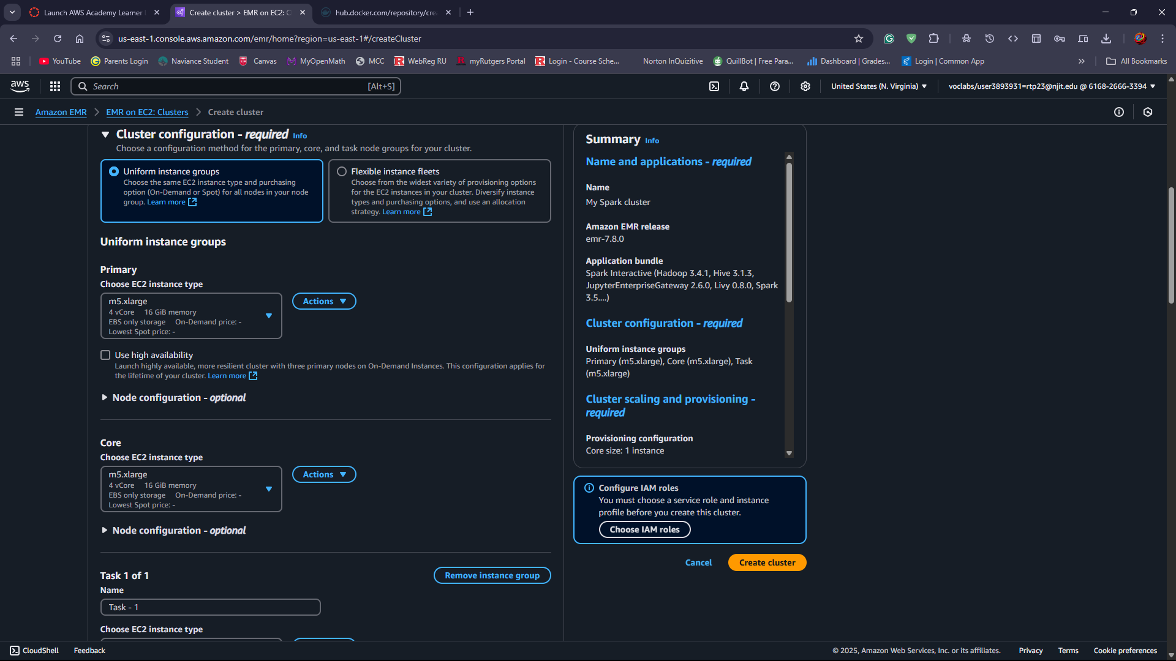

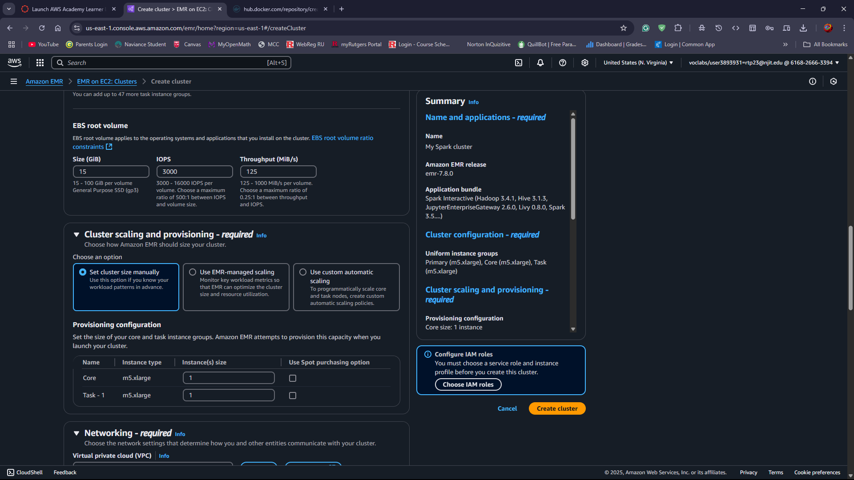

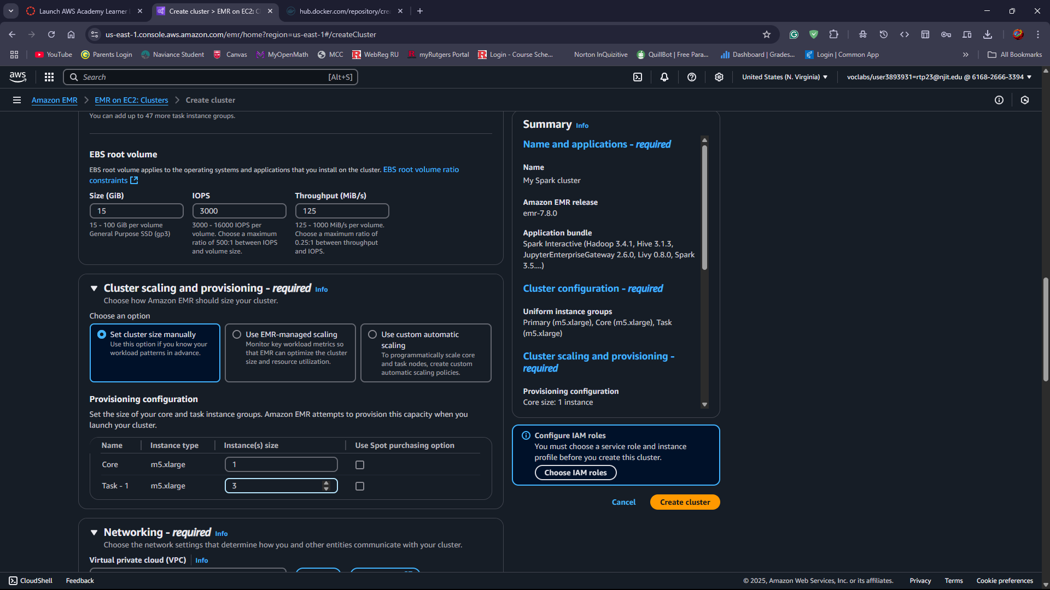

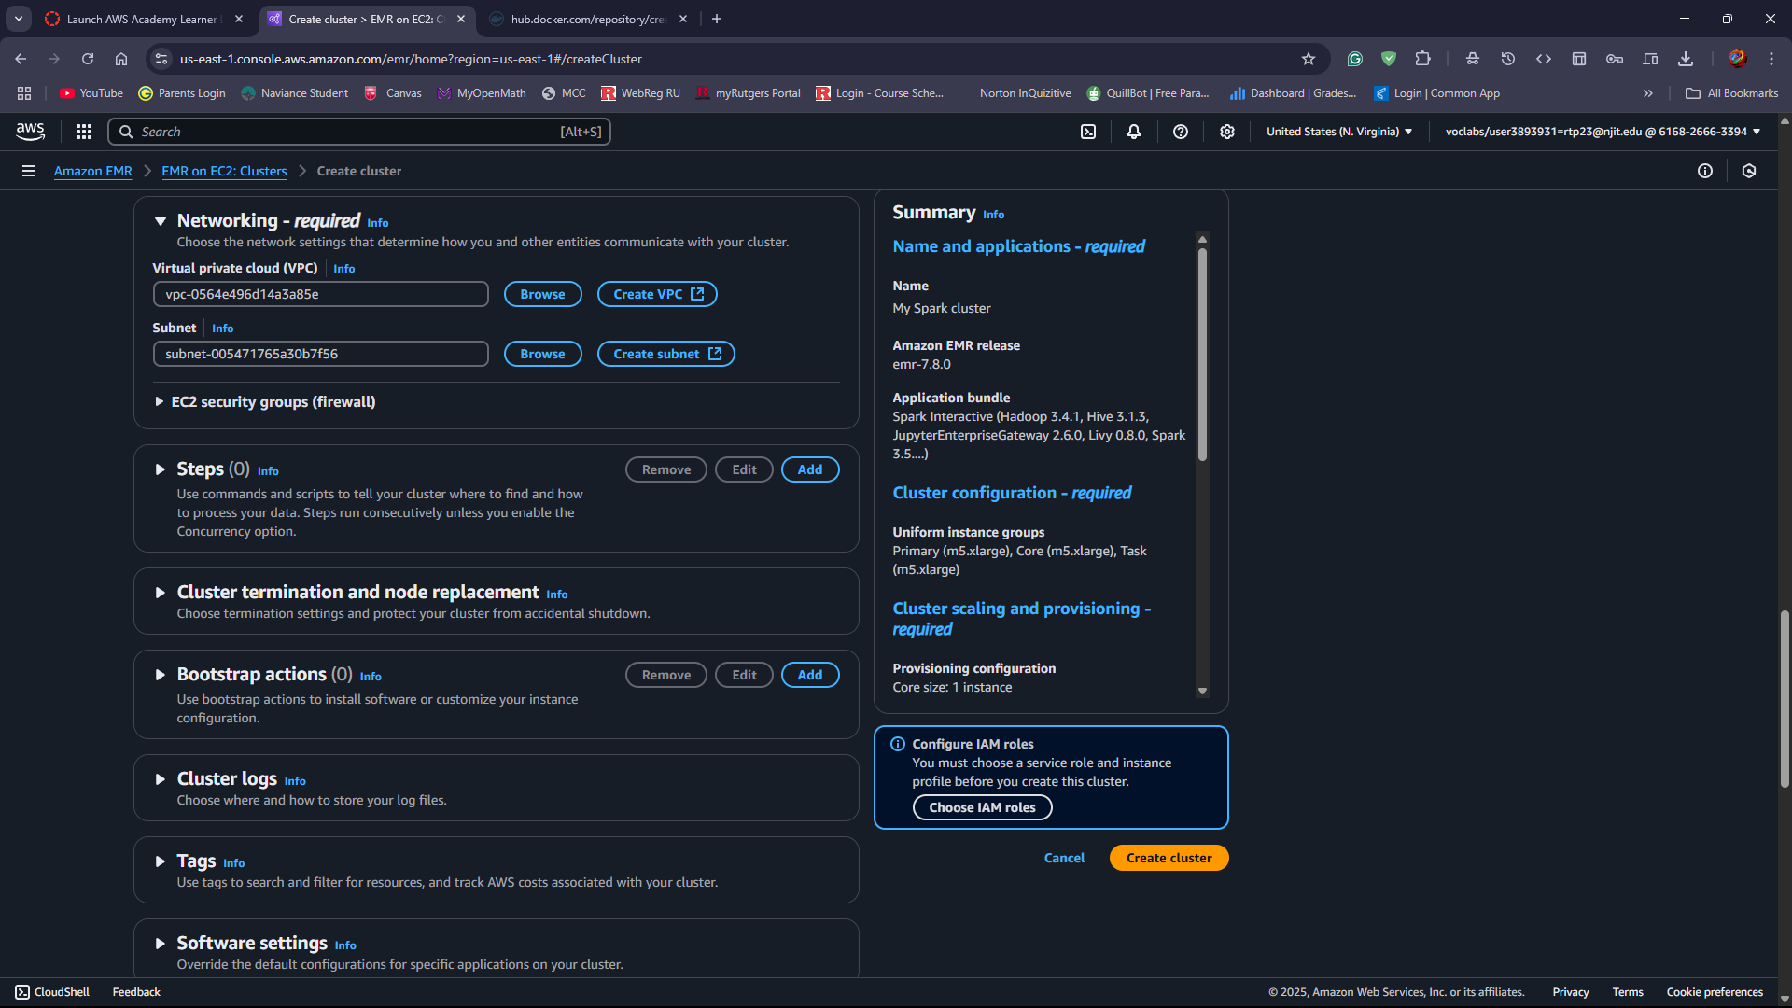

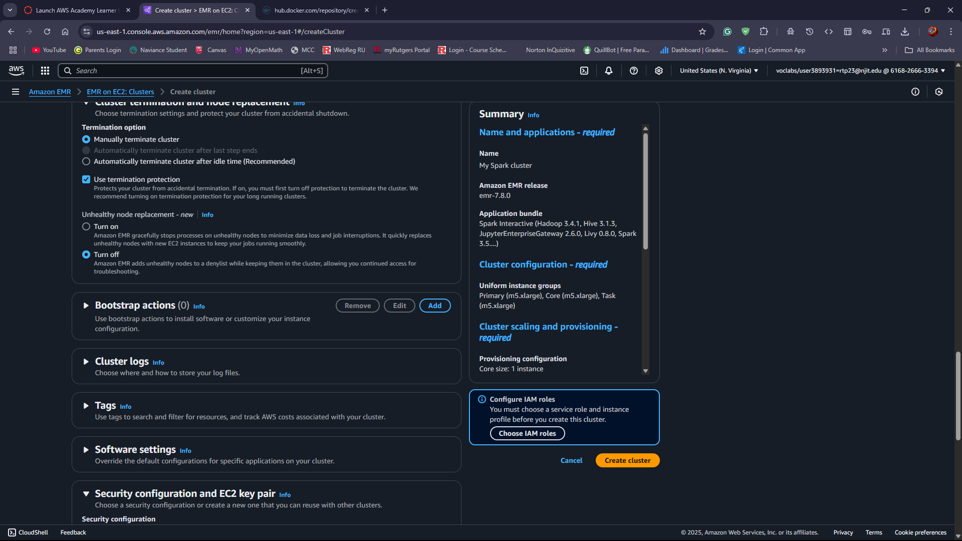

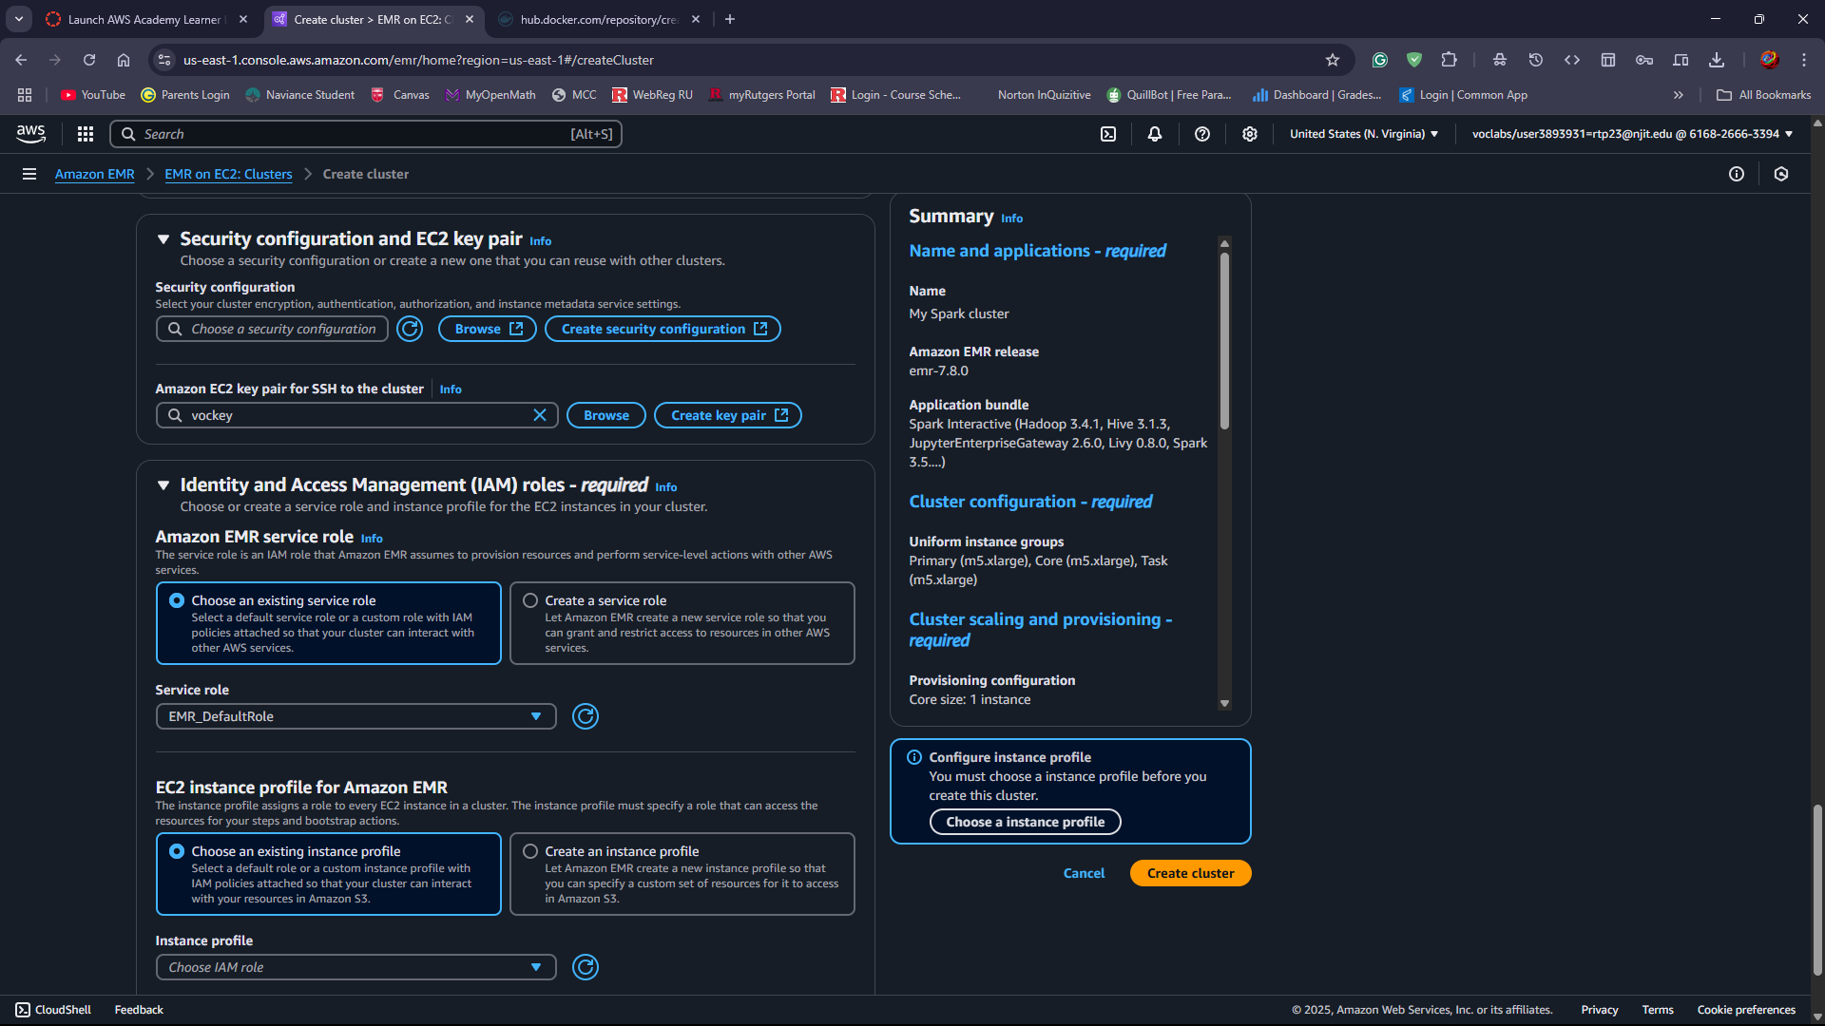

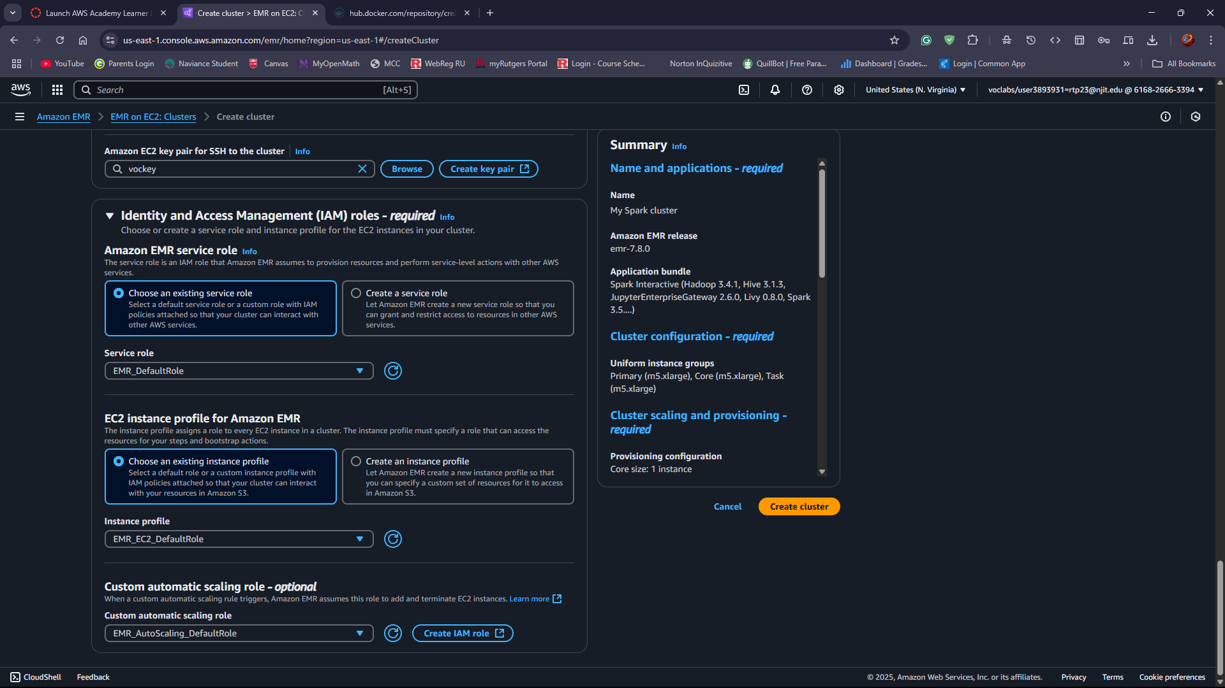

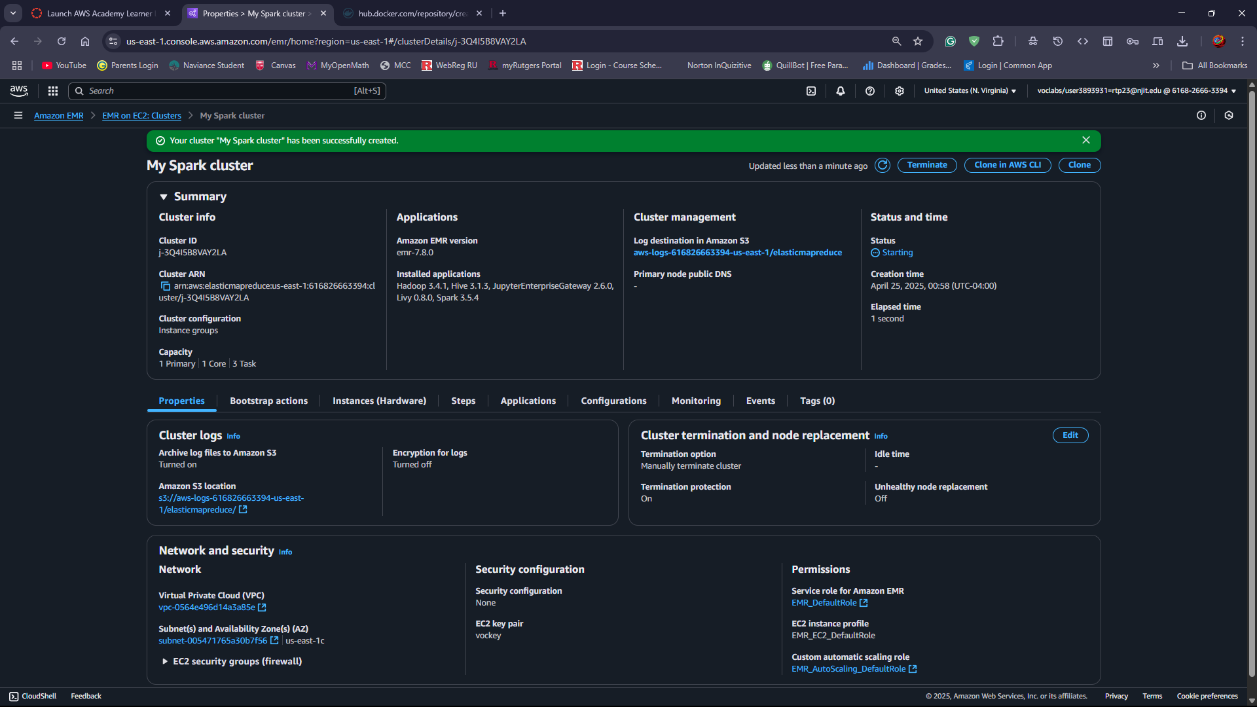

## Step 3: Modify the security group inbound rules for cluster

After the cluster is created now navigate to Network and Security → Click on Expand EC2 security groups → Click on core and task nodes.

And then click on edit the inbound rules to allow SSH access from your IP address.

## Follow the screenshots below

## Step 4: Connect to the Master Node and transfer files

After the cluster is running -> select the cluster and go to the Master Public DNS -> Click on Connect and follow the instructions to SSH into the master node -> after selecting master node click on connect.

Follow steps below on screenshot

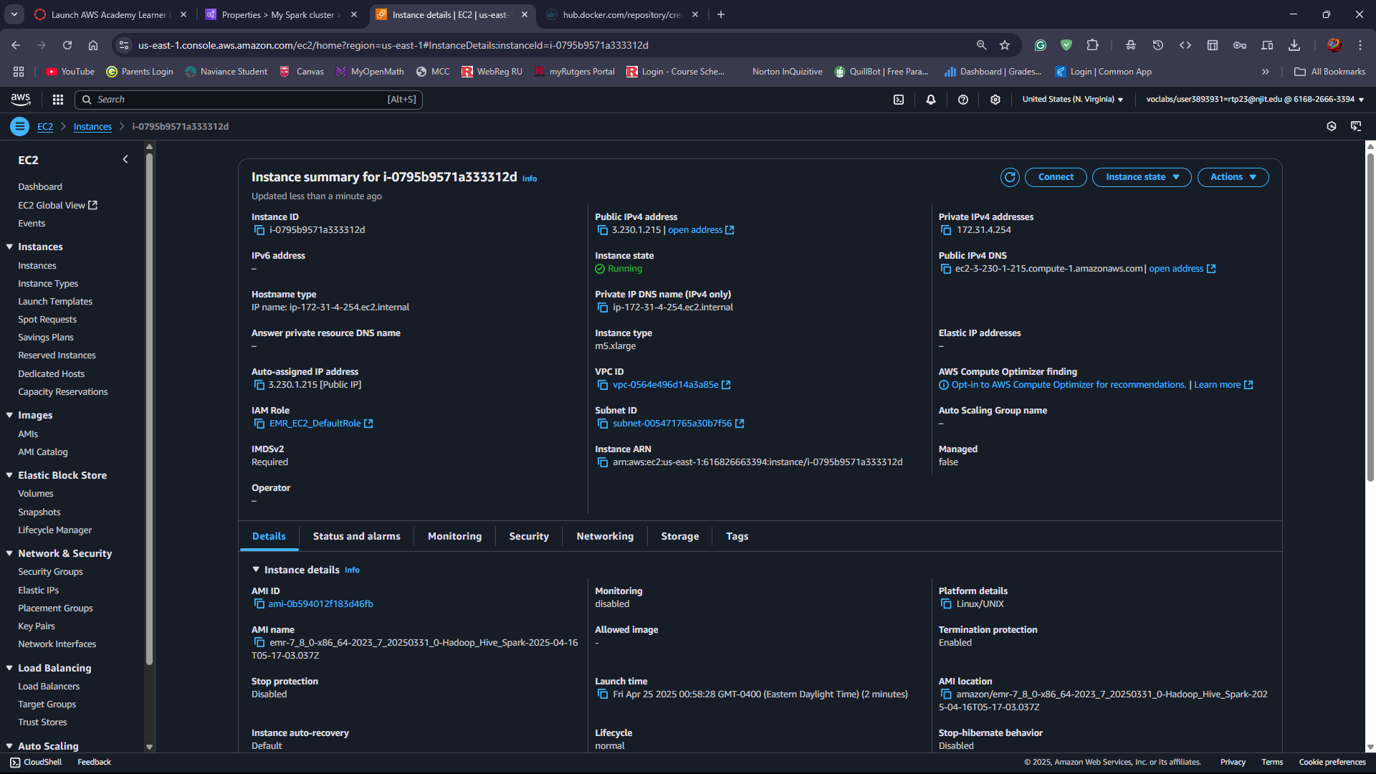

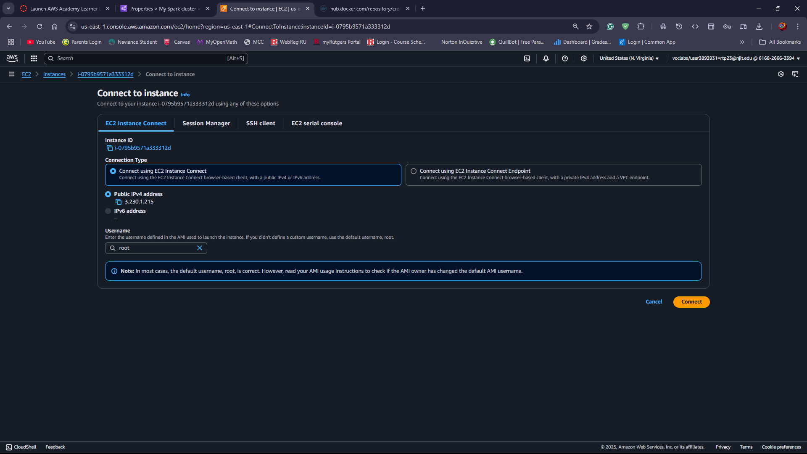

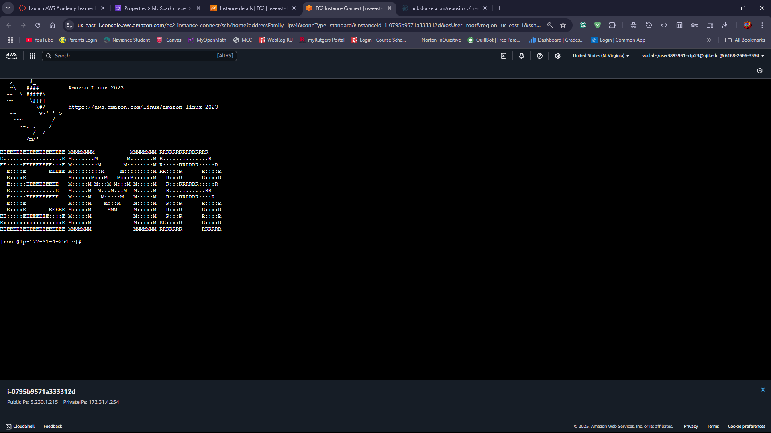

## Step 5: Execute training.py ML application

First Install Git by entering command

sudo yum install git

Now clone the project with the github repository

git clone https://github.com/RPT23/pa2

after that navigate to project directory

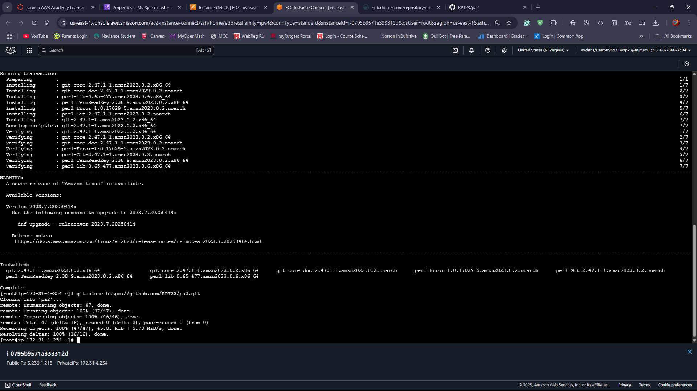

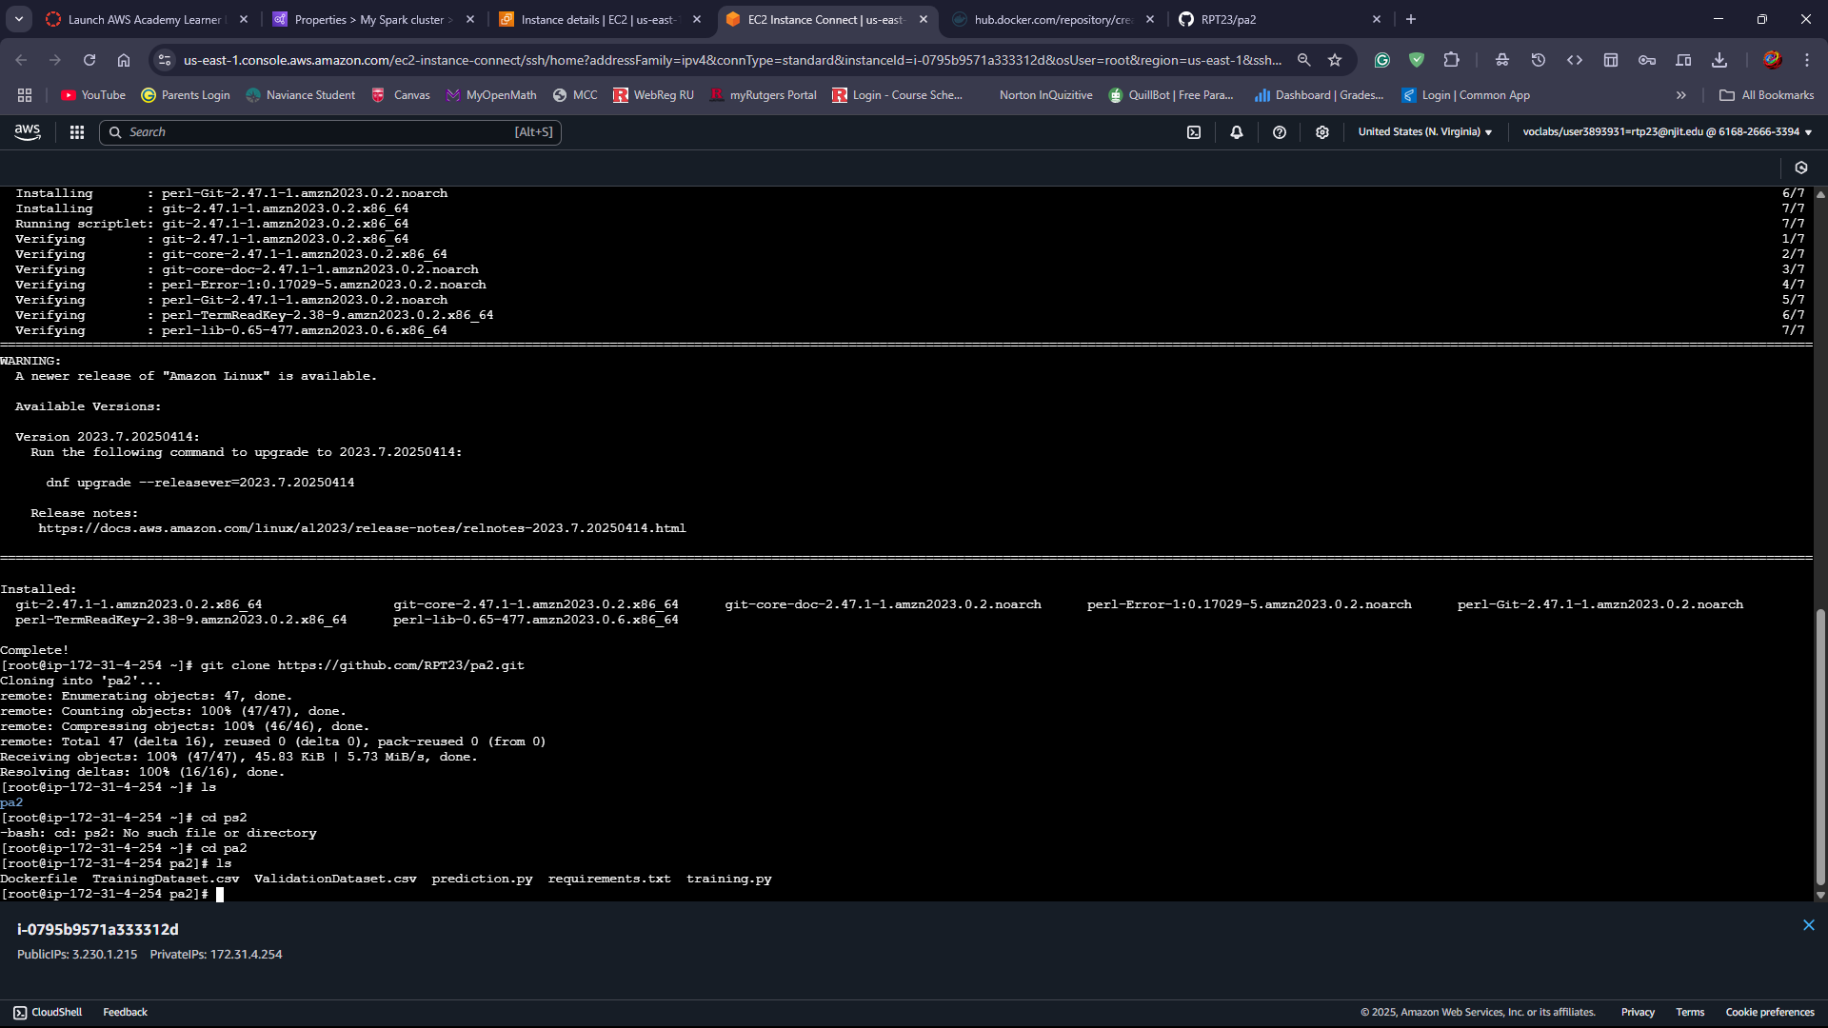

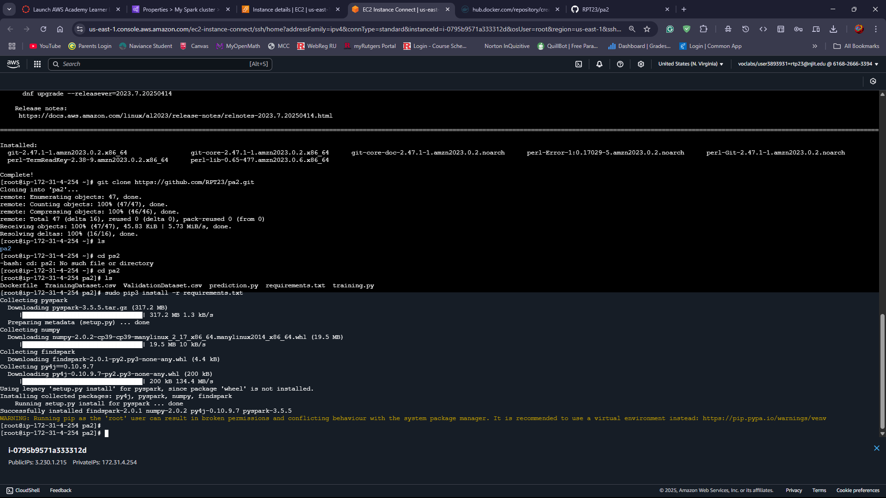

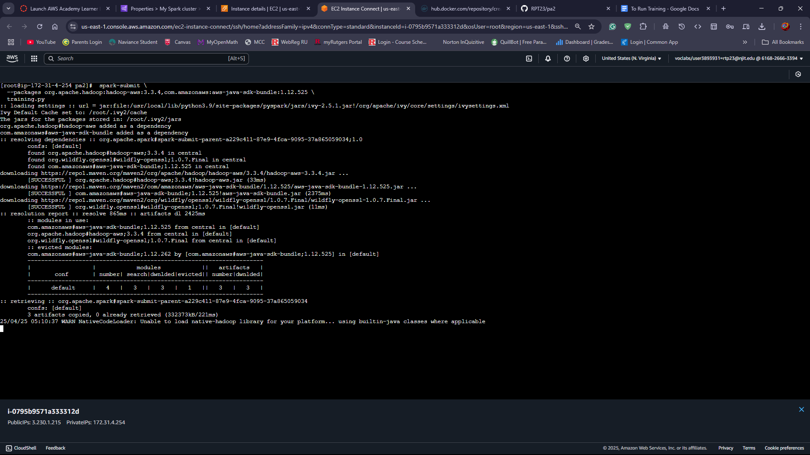

Now install required python libraries by following command

sudo pip3 install -r requirements.txt

Then, run the training script with spark

sudo spark-submit training.py

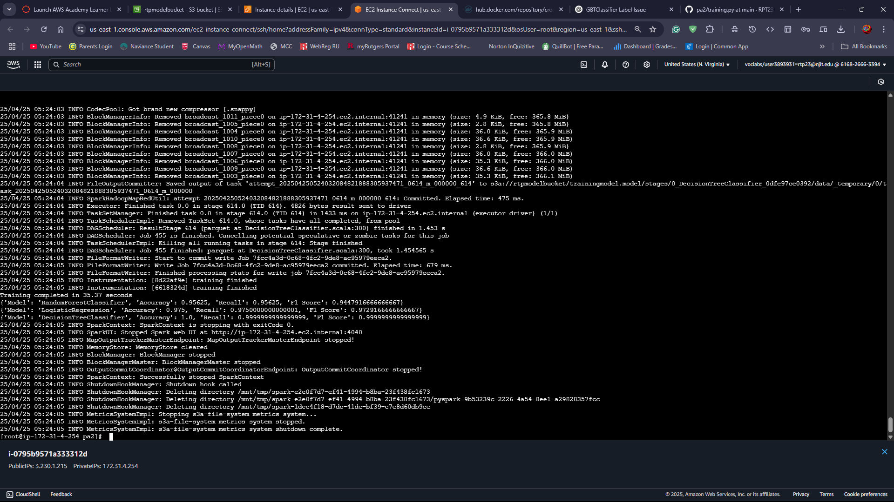

Now, the training script will train a machine learning model using the EMR cluster and automatically upload the best model to the S3 bucket as “trainingmodel.model”

## Step 6: Terminate EMR Cluster

After successfully completing the model training and the model is saved, terminate the EMR cluster. If prompted, make sure to turn off the termination protection and proceed to terminate the cluster.

Follow the screenshot below.

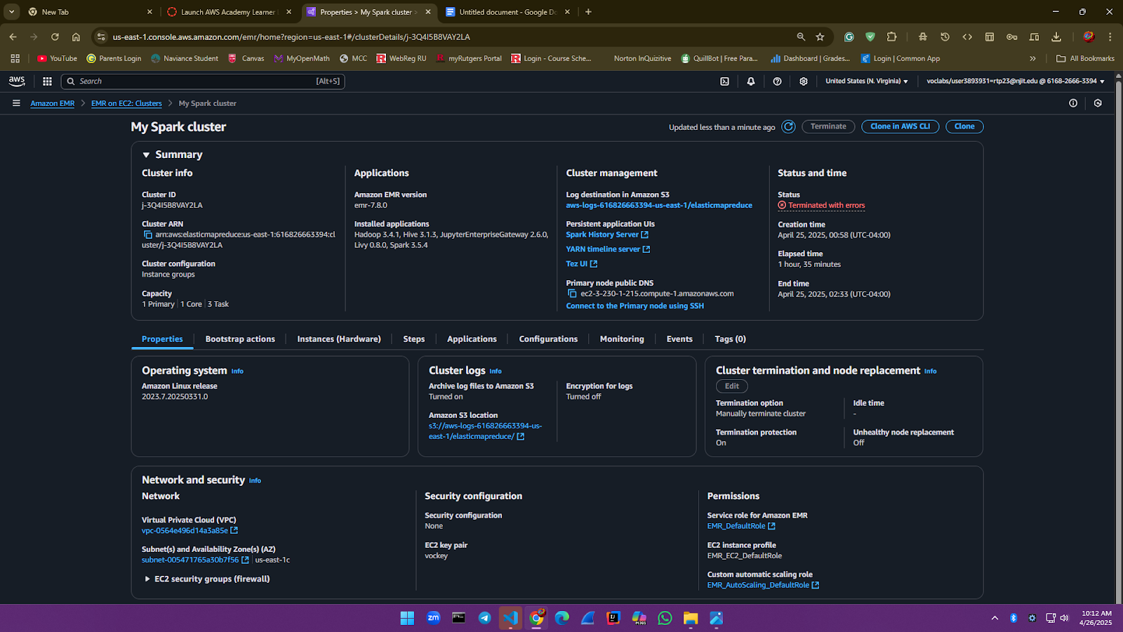

# SECTION 2: AWS Cloud setup for running the ML prediction application without using Docker

## Step 1: Using AWS create a standalone EC2 instance

Go to the AWS Console redirect to EC2 and click on launch Instance.

Now, Enter name and select Amazon Linux 2023 AMI as soon on screenshot below.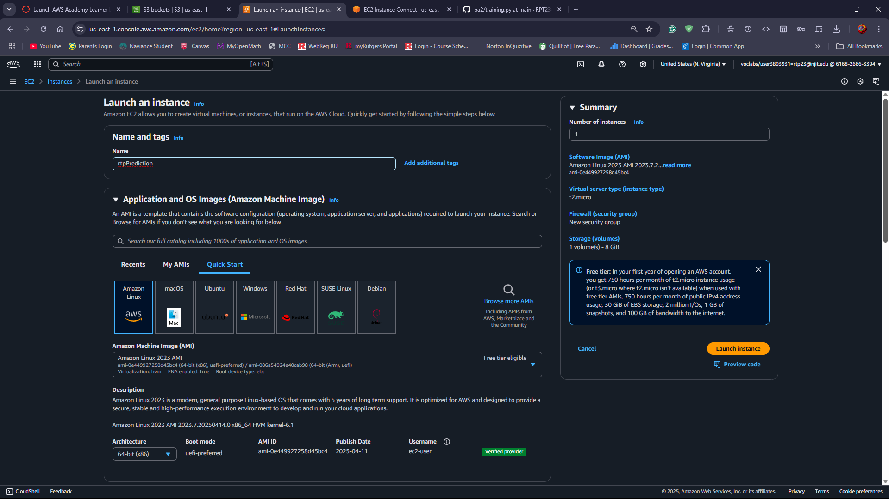

Then, choose instance type t2.medium.

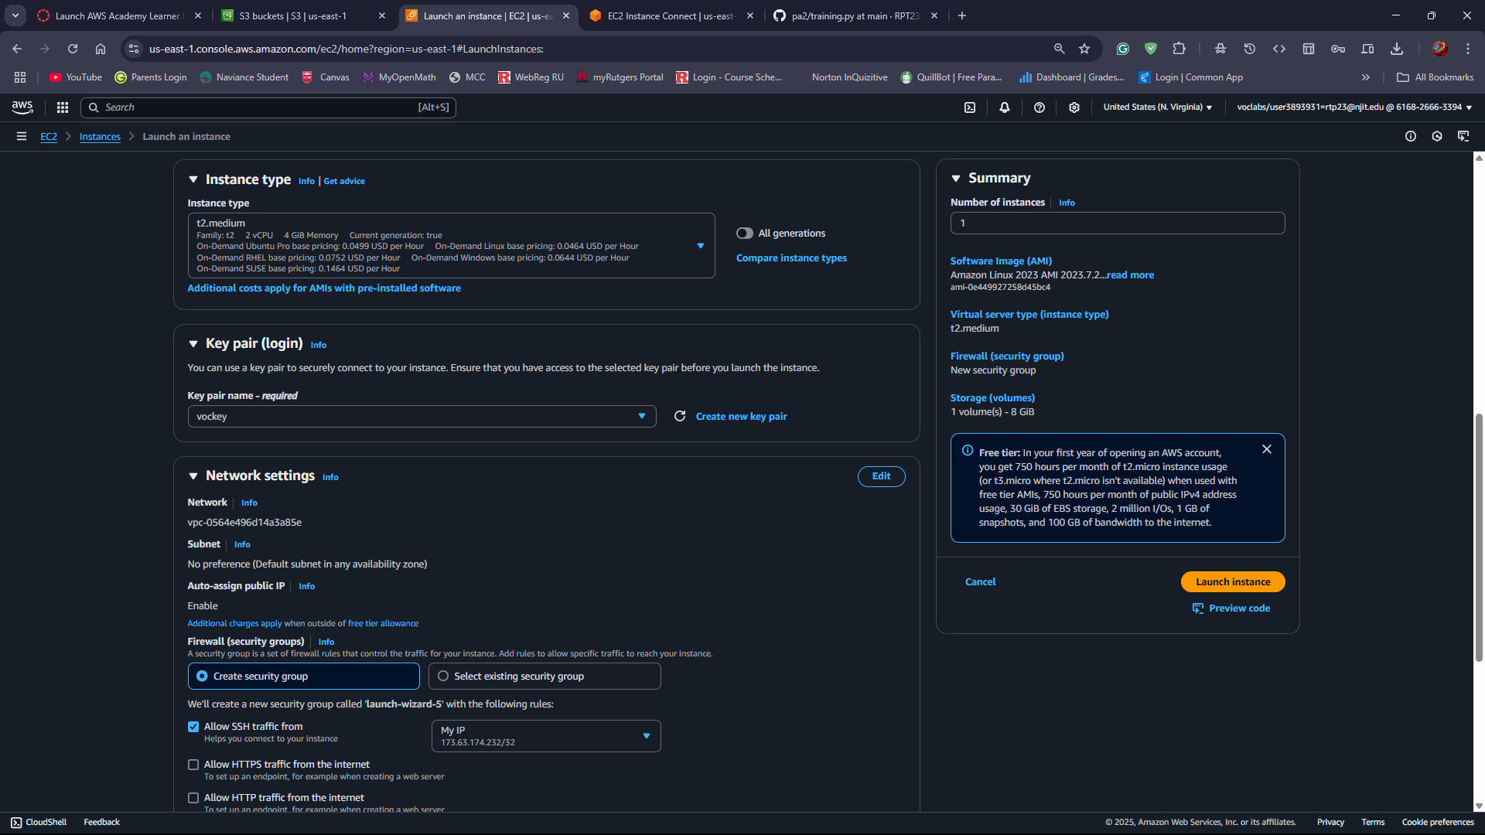

Create or choose an existing security group and add an inbound rule to allow SSH access from MyIP. Make sure to set storage to at least 15 GB of storage to install all required software and tools. Refer to the screenshots below for launching and configuring the EC2 instance.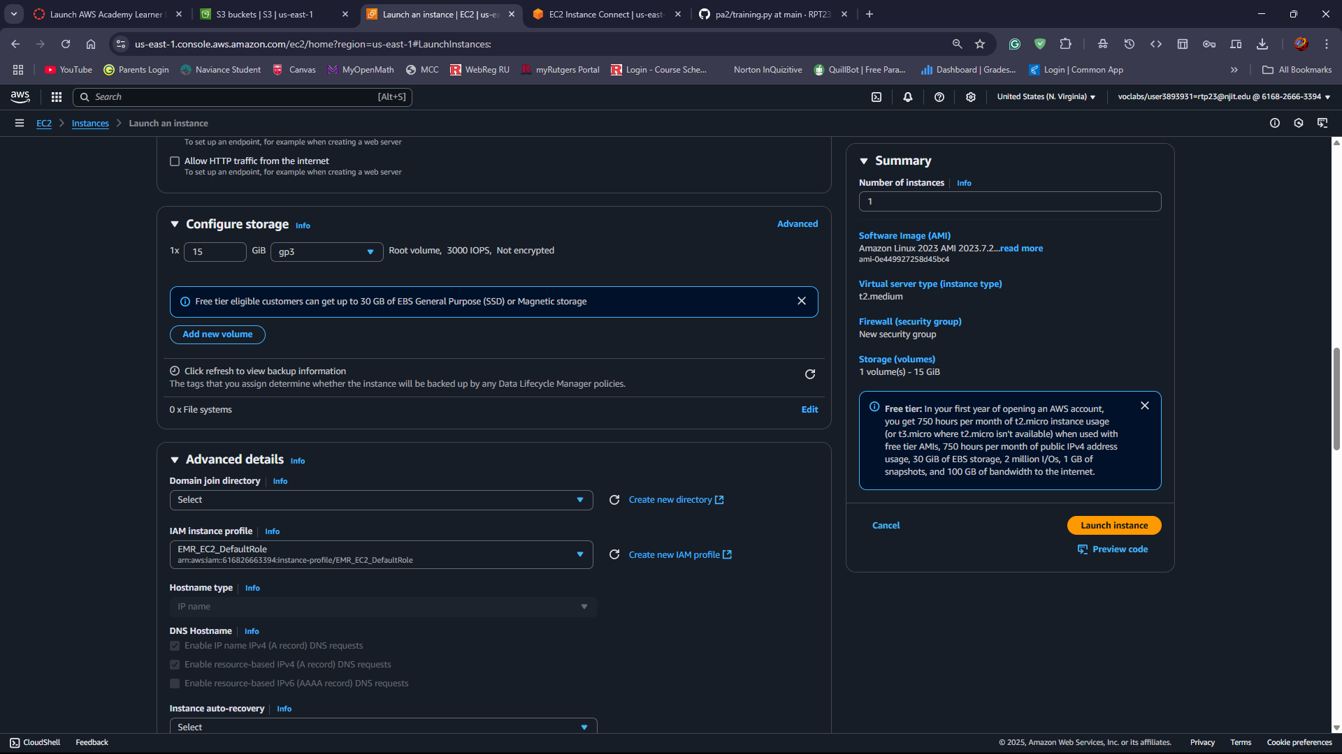

## Step 2: Setup Environment on EC2 instance

Connect to the newly created EC2 instance. Follow the screenshot below.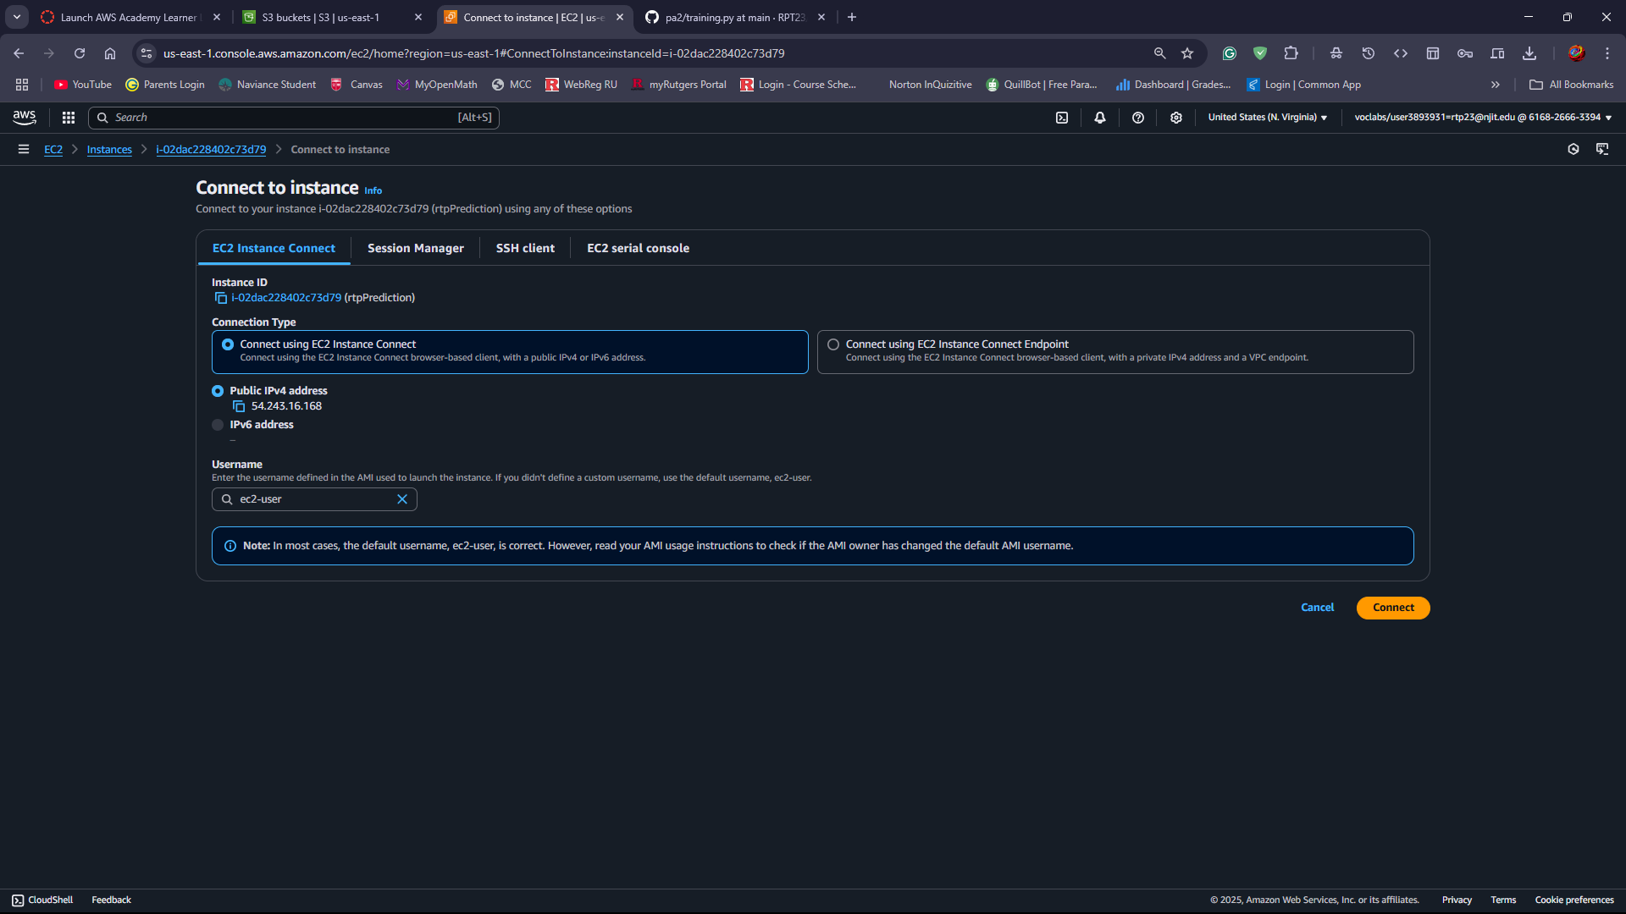

Install Git and clone the project repository

Sudo yum install git

Use the GitHub repository link to clone and download all project files directly onto your EC2 instance.

Git clone git repo clone RPT23/pa2

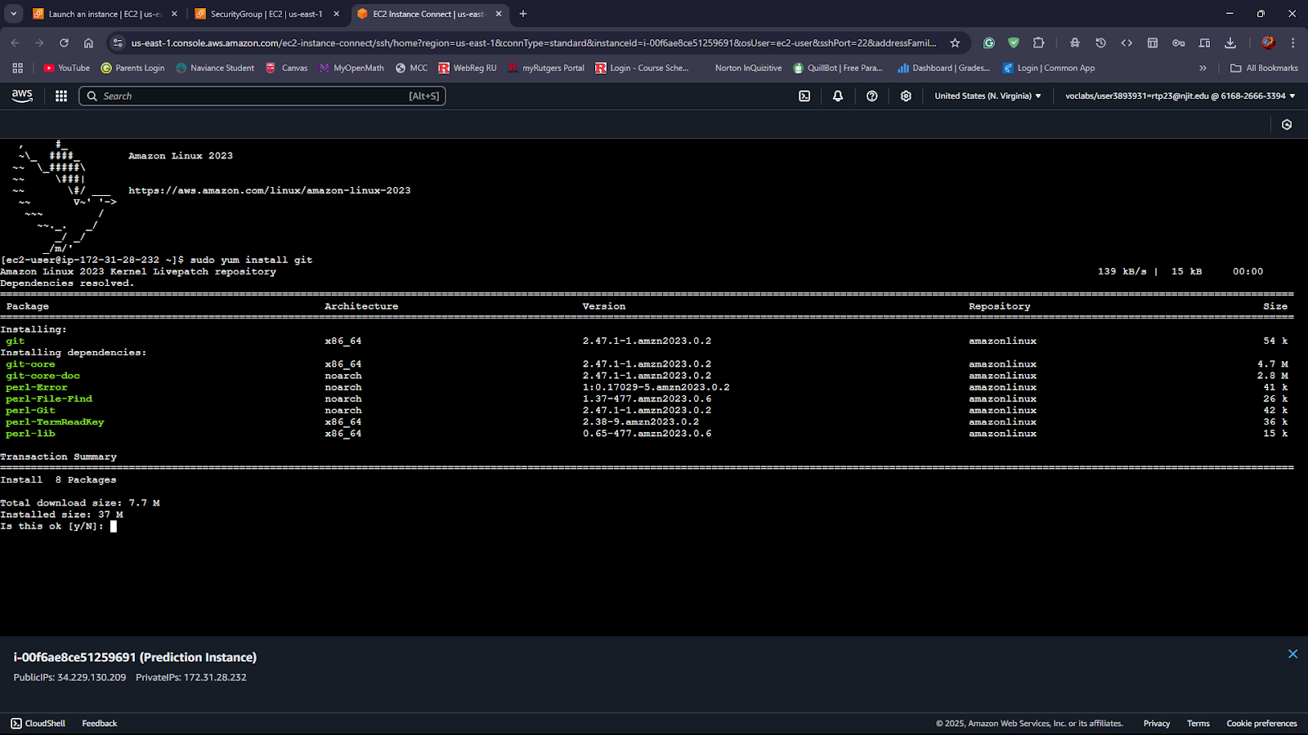

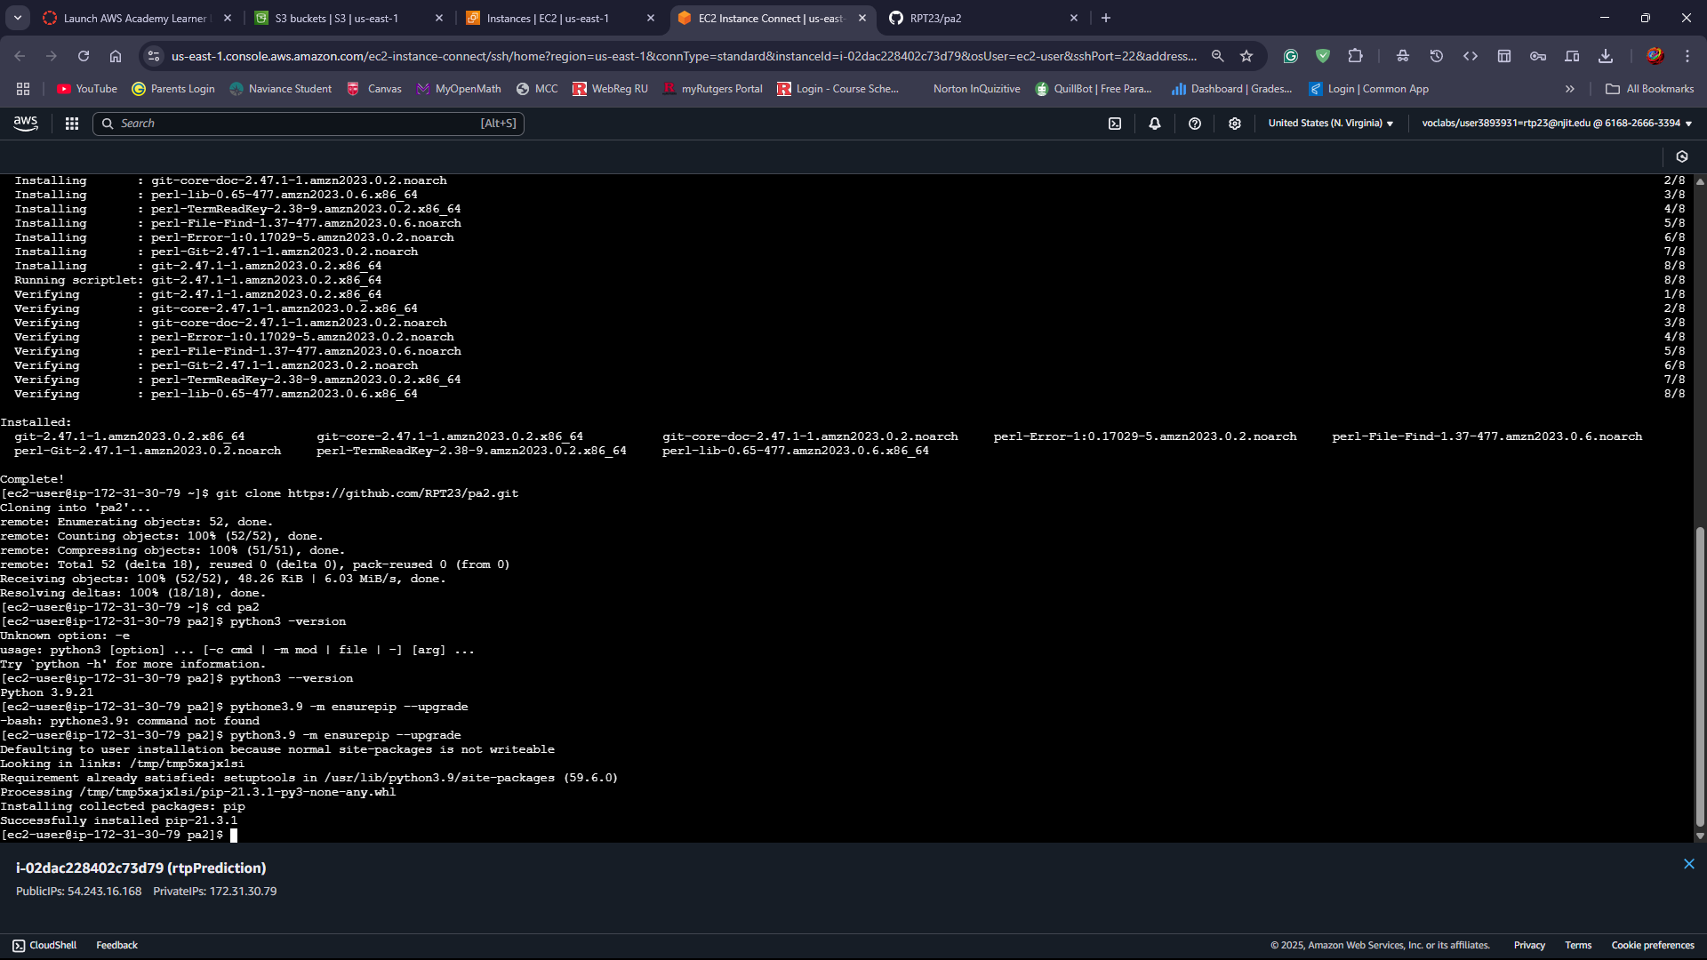

Now, verify the python and pip version on the EC2 instance, and install them if its not already available.

python3 –version

Python3.9 -m ensurepip --upgrade



Install required Python libraries

pip3 install -r requirements.txt

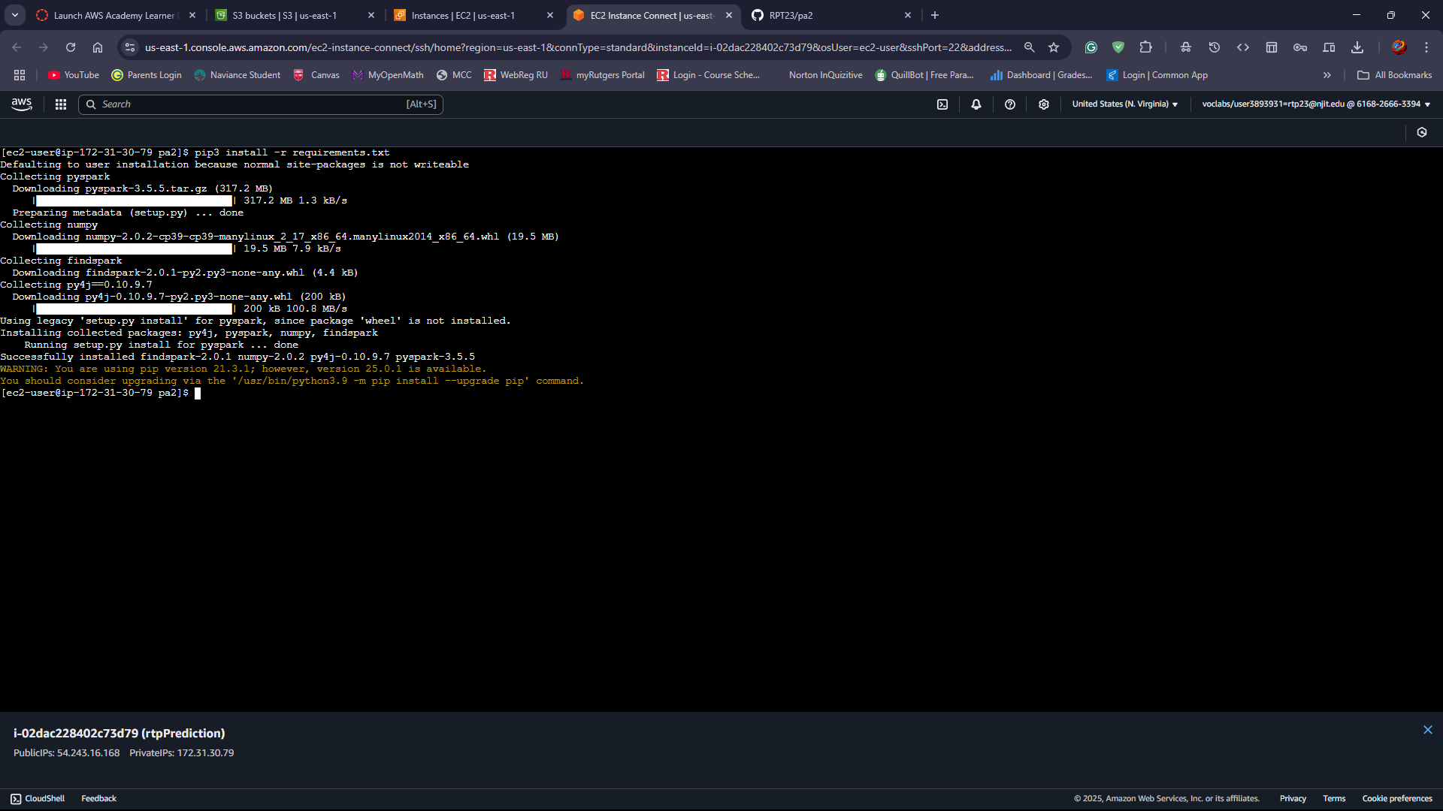

Then, Install java on EC2 instance

sudo yum install java-11-amazon-corretto-devel

Add Java environment varibales by editing .bashrc

nano ~/.bashrc

Add the following lines at the end of the file

export JAVA_HOME=/usr/lib/jvm/java-11-amazon-corretto.x86_64

export PATH=$PATH:$JAVA_HOME/bin

Save and run

source ~/.bashrc

Create a libs directory and download necessary JAR files

wget https://repo1.maven.org/maven2/org/apache/hadoop/hadoop-aws/3.3.1/hadoop-aws-3.3.1.jar -P ~/libs/

wget [https://repo1.maven.org/maven2/com/amazonaws/aws-java-sdk-bundle/1.11.1000/aws-java-sdk-bundle-1.11.1000.jar -P ~/libs/](https://repo1.maven.org/maven2/com/amazonaws/aws-java-sdk-bundle/1.11.1000/aws-java-sdk-bundle-1.11.1000.jar%20-P%20~/libs/)

Follow the screenshot below.

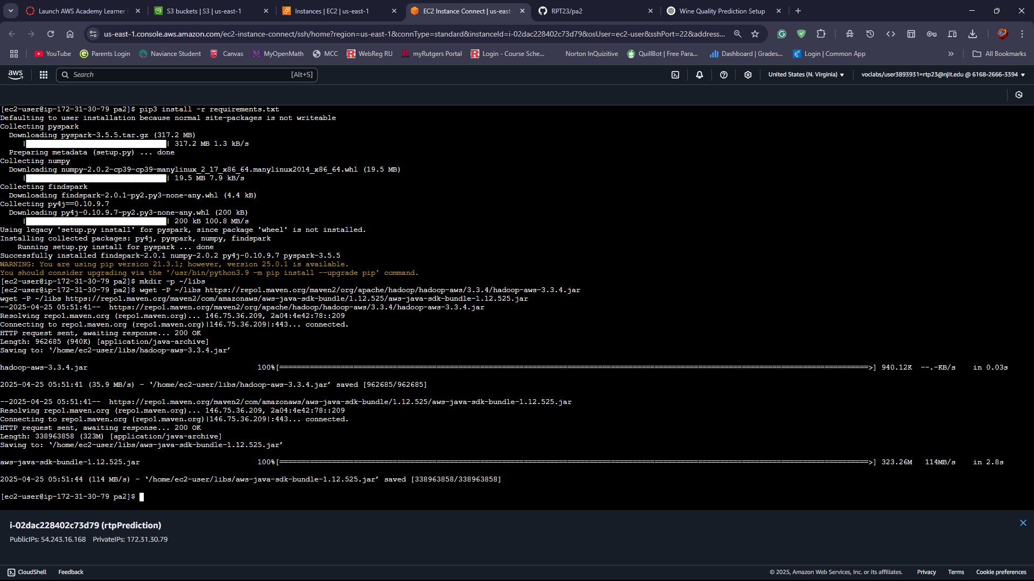

## Step 3: Run prediction.py

Run the prediction.py file using

spark-submit --jars /home/ec2-user/libs/hadoop-aws-3.3.1.jar,/home/ec2-user/libs/aws-java-sdk-bundle-1.11.1000.jar prediction.py

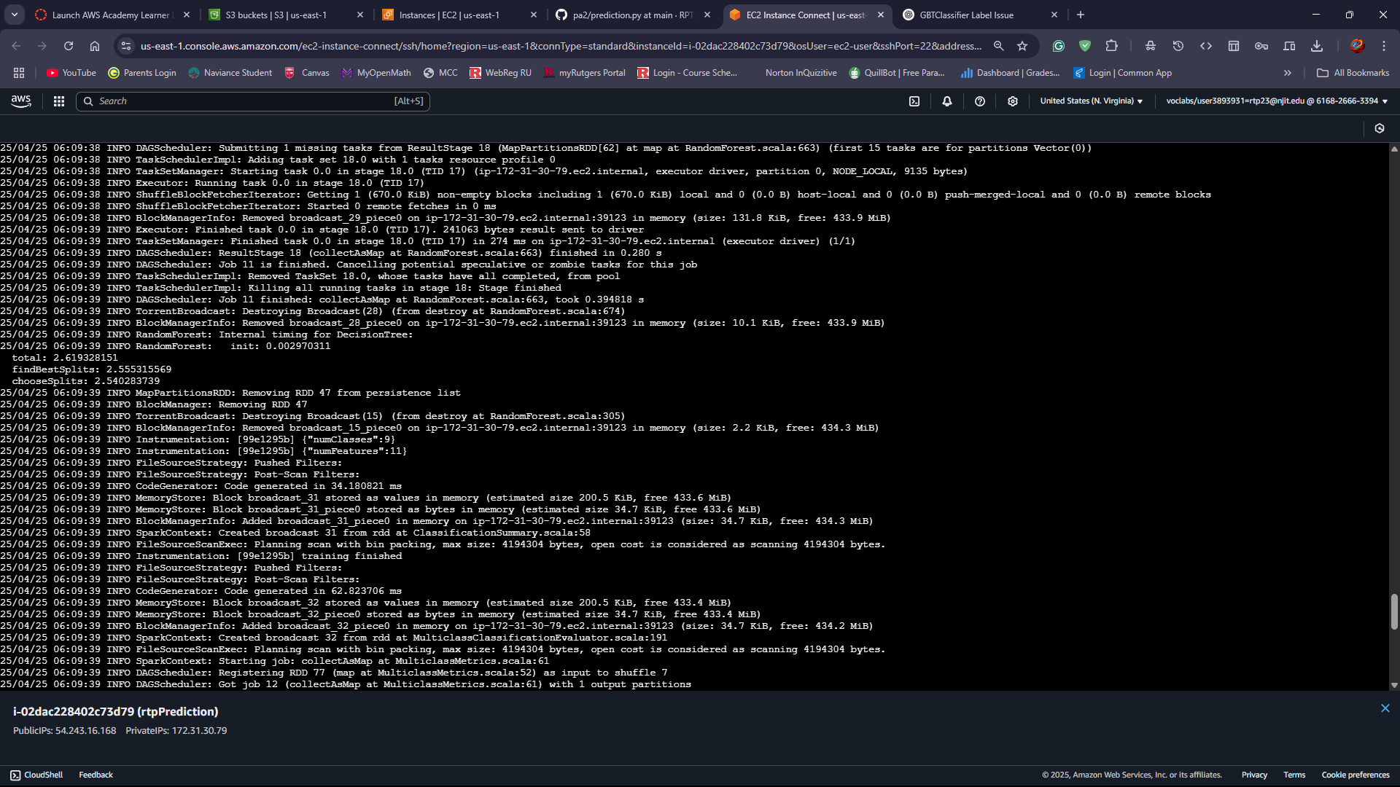

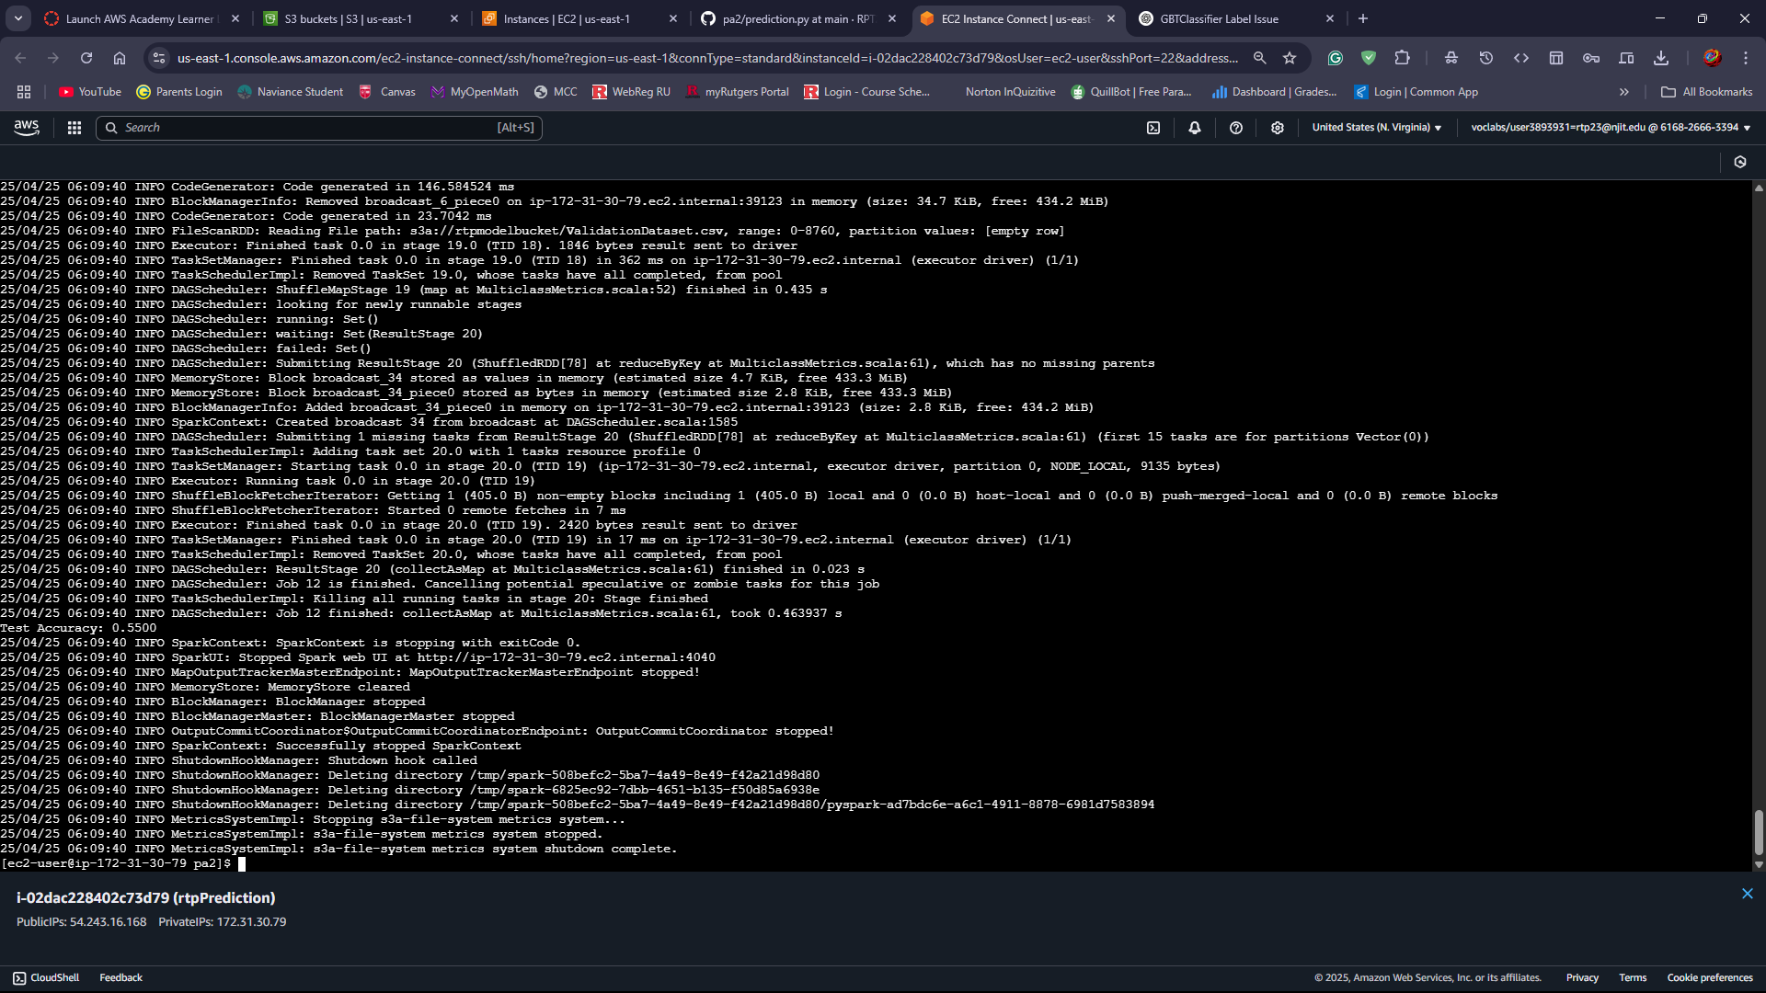

# SECTION 3: Create Docker image and push to Docker repository

## Step 1: Build Docker Image

## docker build -t aws-spark-training.

## docker images

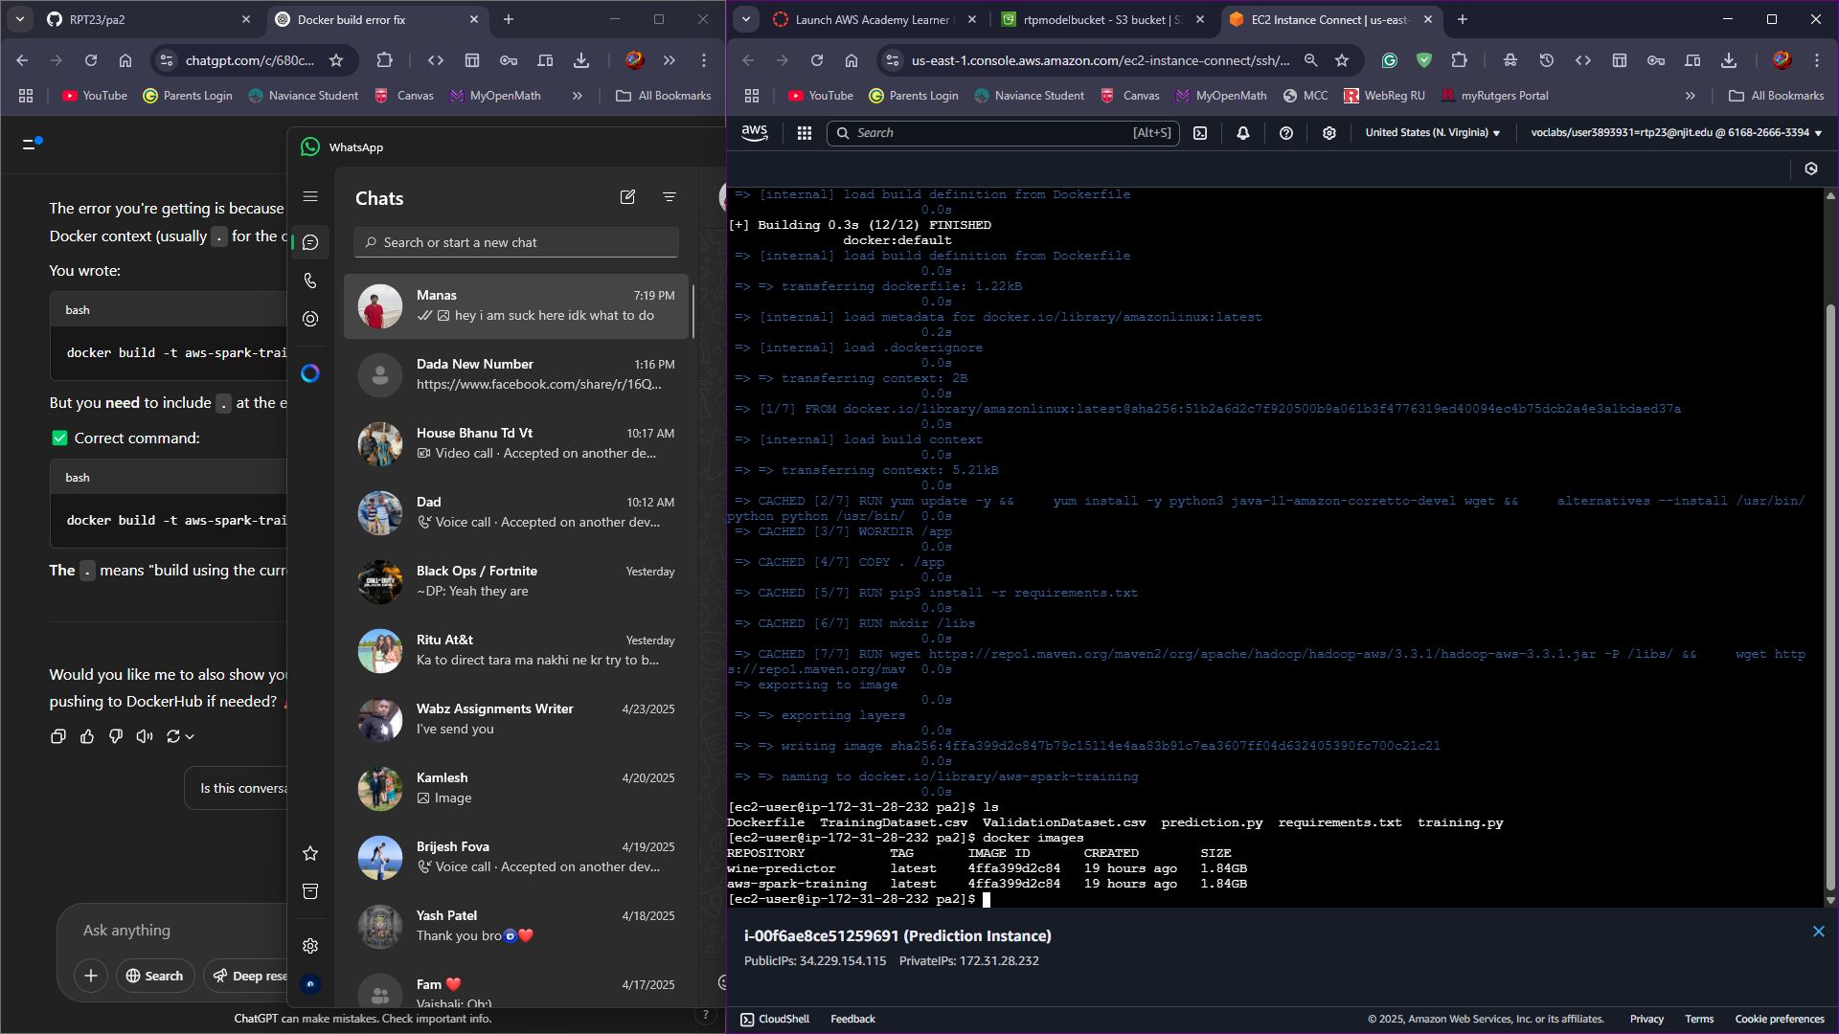

## Step 2: Push Docker Image to Docker Hub and then go to docker repository to verify the uploaded image

Refer to the screenshots below for Docker process.

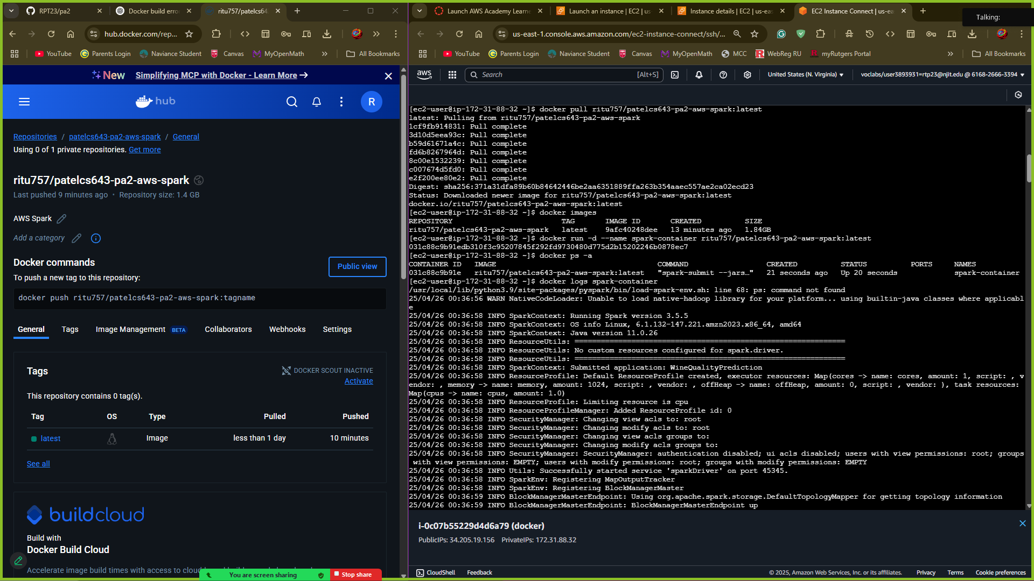

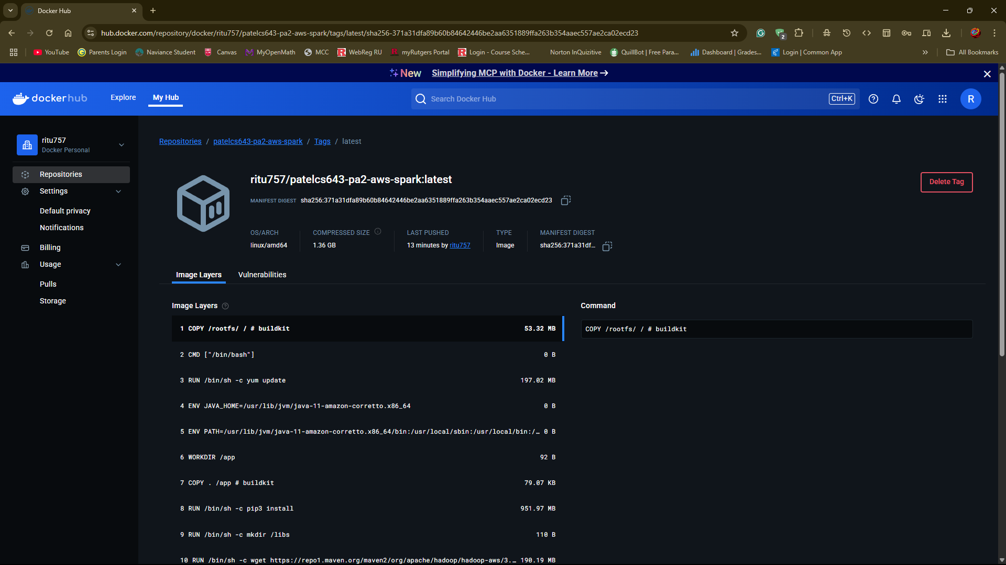

# SECTION 4: Run Docker image on new EC2 instance

## Step 1: Install and Start Docker on EC2 instance

## sudo yum install docker -y

## sudo service docker start

## sudo usermod -aG docker ec2-user

## Step 2: Verify and Run Docker Image

Using command

docker info

Refer to the screenshot below for Docker setup verification.

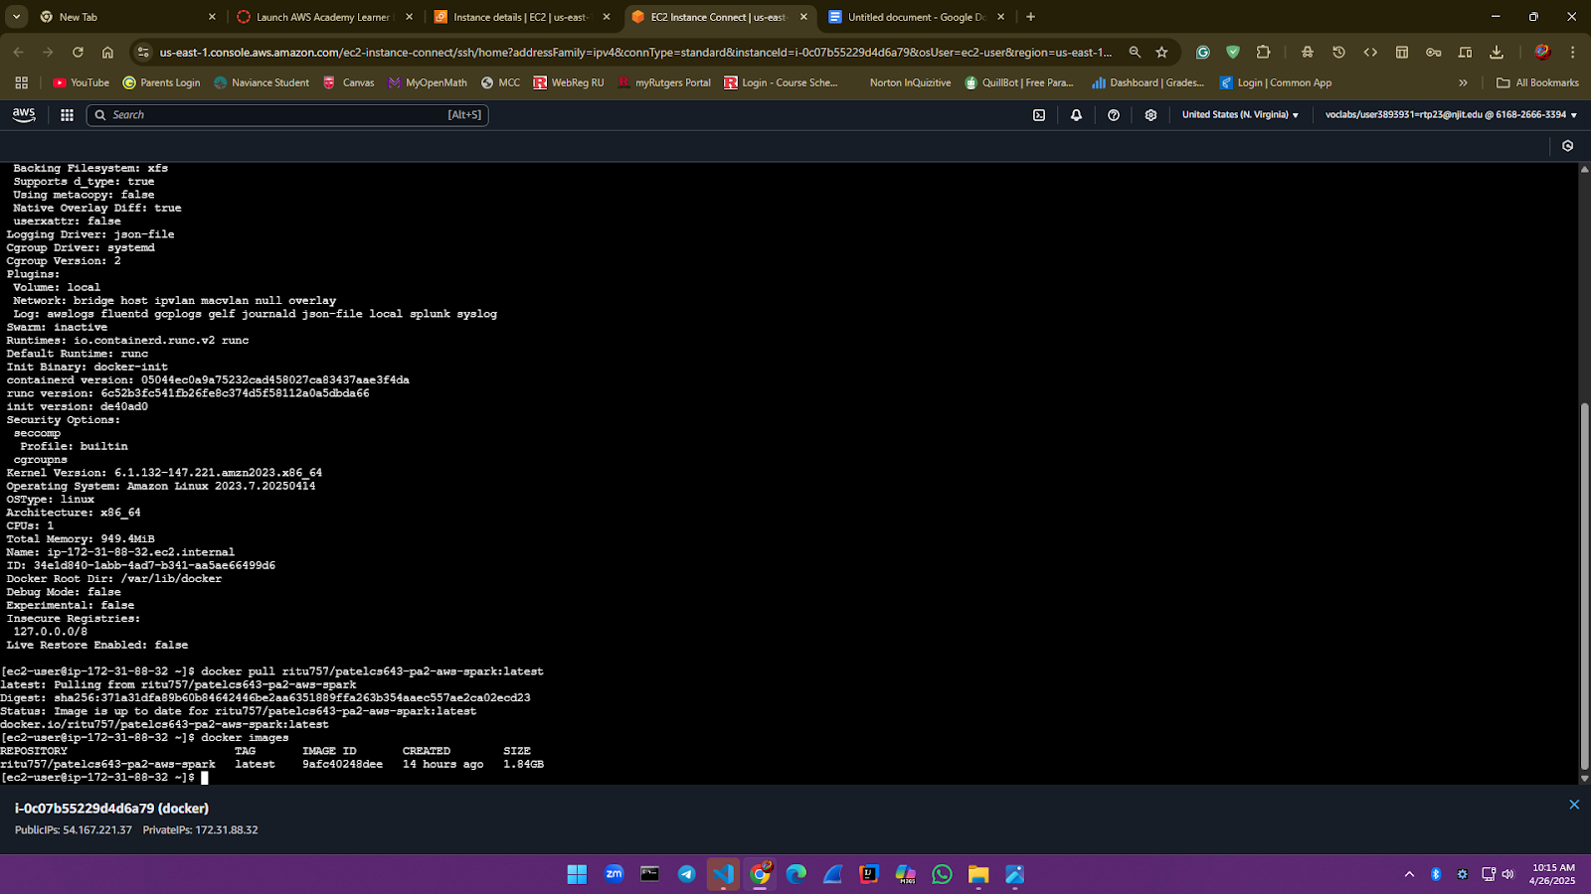

Pull your Docker image

docker pull ritu757/patelcs643-pa2-aws-spark:latest

docker images



Now Run the pulled image using command

docker run -d --name spark-container ritu757/patelcs643-pa2-aws-spark:latest

Check the container log to see the output

docker logs spark-container

